Taskforce X:

Overview

NutriHelp is an Android application that aims to promote healthy eating habits for Australia's senior population, by providing personalised recipes based on the user's specified health conditions and nutritional preferences. Our goal is to decrease the number of elderly people that are either malnourished or at risk of malnutrition, promote nutritional health through food intake and increase transparency and awareness of our user’s current nutritional health.

Features

* NutriHelp supports our users in managing their general nutritional wellbeing and the management of nutrient-related diseases and deficiencies through personalised nutritional planning.
* NutriHelp generates nutritional plans by understanding our users' needs. The user tells us their personal characteristics, mobility, nutritional requirements and nutrient-related deficiencies/diseases and we provide nutritional planning, tracking and daily recipes to support the user.
* We support our user's health through nutrition derived from food, giving more control to the user over their nutritional health.
* Our daily recipe plan provides flexibility, select which time of day you would like meals provided, or select your own.
* User are provided with recipe steps and a convenient shopping list.
* The user can shop online within the application using their shopping list or sent it to a family member to collect.
* We provide an abundance of recipes that can be swapped, added, deleted and favourited.
* The nutritional plan makes sure the user meets and stays within their optimal nutritional targets throughout each day, assisting the user to maintain and improve their health.
* As the users’ health changes over time, their preferences can be updated and the application will respond to their changing health.
* We’ll keep their family/carer and GP up to date with their nutritional health.

Benefits

NutriHelp makes sure that our users maintain a healthy, balanced diet specific to their individual needs. It takes away the complicated guesswork and ensures that seniors stay healthy and looked after!

Images

Screenshots that can be used for Project X can be found in Taskforce X Summary .zip folder.

Link:

<https://deakin365.sharepoint.com/:f:/r/sites/GopherIndustries2/Shared%20Documents/Team%20TaskForceX/T3%202022/Project%20X%20Content?csf=1&web=1&e=NWg2GE>

Avanger:

understanding that you want content over HTML - Just trying to make life easy for you to implement

React – HTML Code

import './App.css';   
   
function App() {   
    return (   
        <div className="App">   
            <div className="Introduction">   
                <h1>Medi</h1>   
                <h2>A Chatbot System for Remote Health Monitoring</h2>   
                <p> At Gopher industries we have created a chatbot system call “Medi” that works as a personal assistant   
                    for   
                    our intended demographic population to interact with the Gopher Suit and act as a frontage that is   
                    the   
                    introduction to the products that Gopher houses. <br/>   
                    Medi allows users to chat to it as if it was a human interaction helping them with anything from   
                    pain   
                    assessments to water consumption, nutritional advice and log in with their patient ID. <br/>   
                    Medi is designed for its users being easy to use, interacts in a friendly human way and will   
                    eventually be   
                    able to be interacted with via both text and voice – making the product accessible for whoever needs   
                    to use   
                    it. <br/>   
                    With future implementations and testing of GUI environments that suits our users, it is an exciting   
                    time for   
                    Medi with graphical implementations and unlimited additions available – Medi is proud to be the face   
                    of the   
                    Gopher Range!   
                </p>   
            </div>   
   
            <div className="Features">   
                <h1>Features Within Our Application Will Include</h1>   
   
                <h2>Pain Assessment Questionnaire</h2>   
                <p>Ability for our users to log and rate their pain assessment to share with authorised health care providers</p>   
   
                <h2>Diet Plan and Tracking</h2>   
                <p>Users are able to plan, monitor and share their diet plan with their authorised health care   
                    providers. It will be a space where they can keep track of their nutrition and diet plans and   
                    with a quick reference on a day to day basis of their nutritional intake   
                </p>   
   
                <h2>Water Consumption and Tracking</h2>   
                <p>For anyone but in particular, the demographic that is using our app, tracking water consumption daily is important. Our MEDI will be able to   
                    log a daily water goal, graphically retrieve how much their consumption and motivate them along the way to reach their goal!   
                </p>   
   
                <h2>DataExtraction and Read Write Functionality to our Database</h2>   
                <p> Exciting plans are in the works for medi to be able to hve read and write function to our   
                    centralised database, meaning that the information   
                    that is entered into MEDI can be logged to the other Gopher logs and vice versa. Meaning that MEDI   
                    is the centralised product that users can interact with for all of their health needs.   
                </p>   
            </div>   
        </div>   
    );   
}   
export default App;

CSS Code (However, this incredibly basic because I understand you will have a centralised format that you will use) 

.Introduction {   
  display: block;   
  margin: 3cm;   
  border: 15px solid lightblue;   
  text-align: center;   
  padding: 2cm;   
}   
   
.Features {   
  display: block;   
  margin: 3cm;   
  border: 15px solid lightblue;   
  text-align: center;   
  padding: 2cm;   
}

Website Format    
Again understanding that you want content over CSS - Just trying to make life easy for you to implement    
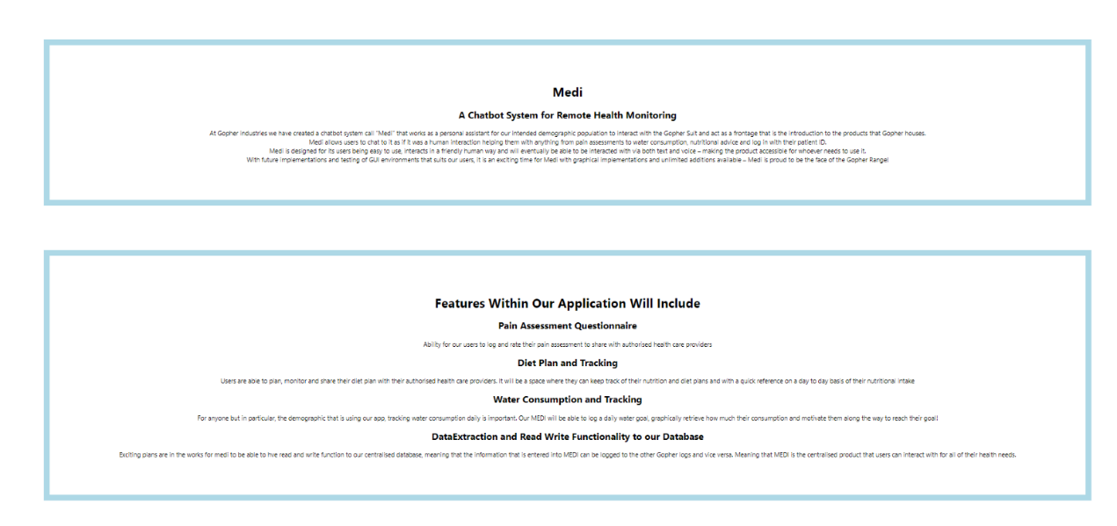

GitHub Link   
<https://github.com/Delljones/Avengers_Biography_ProjectX>

Main JS file    
<https://github.com/Delljones/Avengers_Biography_ProjectX/blob/main/src/App.js>

Main CSS - Completely changeable  - made basic on purpose    
<https://github.com/Delljones/Avengers_Biography_ProjectX/blob/main/src/App.css>

Team Guardians:

Many health conditions go unnoticed until it is too late, particularly in the elderly population, where a decline in health is sometimes associated with ageing and thus ignored. Guardian aims to provide a solution to this ongoing problem.

Guardian is an activity monitoring and profiling system for the aged care sector with plans to expand to residential homes. Guardian uses a non-invasive radar technology to record a user’s activity and classify these activities over time. Guardian utilises the classified data to predict possible physical and mental health conditions associated with that behaviour. Guardian alerts the elderly person and their family members to see a health professional. Additionally, Guardian detects more urgent incidents such as fall detection.

Features

* Monitoring and profiling patient activities.
* Alerting caregivers and supervisors during an emergency.
* Predicting potential physical and mental health conditions at an early stage.
* Providing suggestions to see a health professional based on health issue detected.
* Encouraging positive activities.
* Generating weekly and monthly activity dashboard.
* Providing access to accurate real-time visualisation and position of patient(s).
* Ability to define a baseline for a patient.
* User management allowing for defining Patient, Carer, and Admin users.

Benefits

* Early detection of physical and mental health conditions.
* Peace of mind for both users and family members who cannot physically keep an eye on their elderly family members.
* Elderly people can live at home independently for longer.
* Easy for caregivers to monitor multiple patient activities.

#### Customer Segment

Guardian’s primary customer is aged care facilities with a plan to expand our scope to carers of elderly persons in residential settings.

Keep the following four pictures as original:

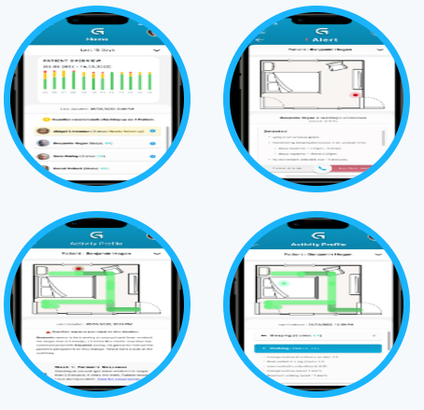

Team Justice League:

Pain as a symptom is most commonly self-assessed and verbal communication is typically the primary source of information for medical practitioners to understand the level of discomfort a patient is experiencing, however when patients are unable to communicate clearly issues of pain mismanagement become significant The goal for this product is to empower age care professional to provide better care and pain management strategies for these vulnerable populations.

Features

Our Product will primarily take the form of an application with the following Features present in the minimum viable product:

* **A Simple, user-friendly UI**
* **A Cloud-based assessment engine**
* **An alert system**
* **A guided questionnaire**

Our team has plans on implementing the following features over a longer-time frame:

* **Integration of wearable devices**
* **Novel technologies for additional data sources**
* **Facial Identification for Authentication**

Benefits

* Increase the accuracy of pain assessments, enabling more efficient pain management strategies and improving quality of life
* Guide caregivers through the process, cutting down on training time and making the pain assessment process easier to perform
* Through implementation of pain history tracking, providers can easily track pain history, empowering recognition of pain trends and allowing for estimation of future needs.
* Providing the data and history needed to construct and carry out a more comprehensive pain a management strategy

#### Customer Segment

* Our targeted user is the healthcare provider who is looking to improve their pain diagnostic capability and enhance their pain tracking and diagnostic capability.

Keep the following three pictures as original:

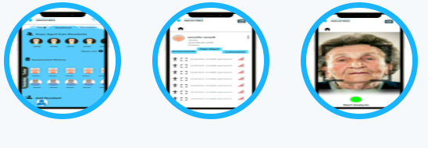

Peacemaker:

At Gopher Industries we are developing a central database, called the Apollo Database, (to host and integrate all the company’s products and manage core services across the company. The goal of Team Peacemaker is to provide the Apollo central database to host and integrate Gopher Industries product suite, centrally manage patient history, provide core services company-wide and eventually enable artificial intelligence data analytics on patient data. . The Apollo Database will enable the storage, access, and retrieval of sensitive personal and health information collated through the various applications offered by Gopher Industries. The Apollo Database employs cloud technologies and cybersecurity practices to ensure the confidentiality, integrity and availability of sensitive health data required for the various applications developed internally within Gopher Industries. The Apollo Database enables access through APIs (Application Programming Interface) for better health outcomes for aged persons. Additionally, the Apollo Database reduces duplication of effort for core services in Gopher Industries. The Apollo Database will also allow the application of advance artificial intelligence analytics in the future, to provide insights and improved services of Gopher Industries customers.

**Benefits**

* Easy for Gopher Industries applications to collect, store and retrieve data
* Continuous access to stored data regardless of time or location
* Enhanced data integration enabling information to be shared between various Gopher Industries applications/services
* Consolidates sensitive information into a single repository, enhancing security across all Gopher Industries services
* Universal data security standards across Gopher Industries (i.e., no weak links)
* Increased efficiency in Gopher Industries
* Reduction in duplication of data across Gopher Industries applications
* Advanced analytics to provide insights to improve services to Gopher Industries customers

#### Target Demographics

* Apollo’s primary market are the internal development teams within Gopher Industries.

**Features**

* Authentication/Authorisation to maintain confidentiality and protect customer privacy
* Audit Logging to track user access and changes to the Apollo Database
* Data Ingestion (i.e., ability to extract data from various sources)
* Scalable Data Storage
* Ability to store structured, semi-structured and unstructured data
* Data Manageability
* Data Security
* Data Analytics
* Data Retrieval
* Data Model Management